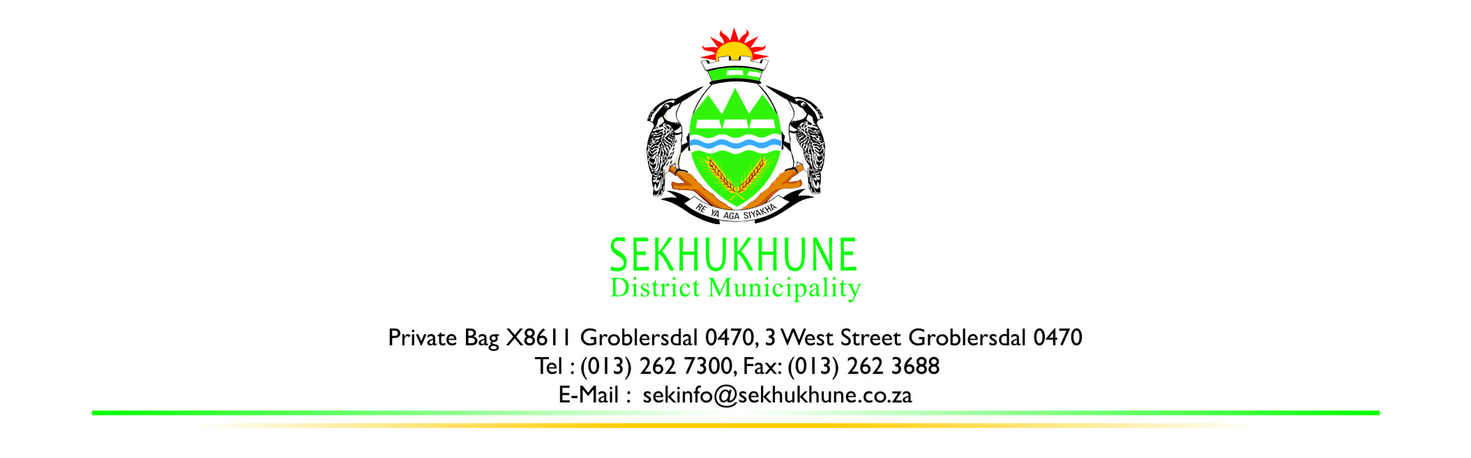

SEKHUKHUNE DISTRICT MUNICIPALITY SMMEs AND COOPERATIVES SUPPORT FUND 2025/2026 APPLICATION FORM

INSTRUCTIONS

- All questions must be answered.
- This programme is meant for SMMEs and Cooperatives residing in Sekhukhune District only and therefore only SMMEs and Cooperatives are eligible to apply.

SUPPORTING DOCUMENTATION REQUIRED

The following documentation must be attached to this application form.

- Proof of registration of the Co-operative or SMME
- Company registration number
- Original valid tax clearance certificate or PIN
- Proof of CSD registration
- Certified copies of members’ IDs
- Comprehensive business profile
- Proof of Land or Property ownership (PTO, Title Deed, Lease Agreement, etc.), whichever is applicable
- Attach quotations.
- Bank Account Details (proof of bank details stamped by the bank)

SECTION A: CO-OPERATIVE/SMME DETAILS
Name of the SMME/Cooperative
Level of applicant, please tick: |  |  | New (Start Up) |  |  |  | Existing
Registration no. |  |  |  |  |  |  | Income Tax No.
Details of the contact person:
Name and designation: |  |  |  |  | Cell Phone:
Telephone: |  |  |  |  | Fax (if any):
E-mail Address No.1. |  |  |  |  | E-mail Address No.2.
Physical Address of co-operative (Location of operation/ Place from which the SMME/Cooperative/ conducts business) |  |  |  |  | Postal Address of SMME/Cooperative
Name the main products and/or services provided or produced by your SMME/Cooperative?
Description of Products or Service(s) Main Customers |  |  |  |  |  | Main Customers

Main Competitors
Name | Product

SECTION B: LIST OF MEMBERS
Name and Surname Member |  | Gender  M/F | Race | Youth  Less than 35  Yes/No | Disabled  Yes/No

SECTION C: SUPPORT APPLIED FOR: What assistance does the SMME/Cooperative apply for? (Kindly attach quotations)

Activities (Production Infrastructure, equipment or inputs) |  | Estimated cost
SECTION D: OTHER SOURCES OF SUPPORT RECEIVED

Organization | Type of Support (if monetary state amount in Rand value) | When received

SECTION E: DECLARATION
I hereby declare that the information in this application is a fair and true reflection of our SMMEs/Cooperative. I am aware of the fact that the information which I/we have submitted above will have a material bearing on the adjudication of the application and if it therefore subsequently appears that any information in the application with addendum was not correct, or that certain information was omitted, the Adjudication Committee shall be entitled to withdraw or amend its approval.

I/We have declared that I/we are authorized to make this application

I/we authorize you to make any enquiries in connection with this application.
Name of Authorized official
Designation (Job title/role)
Signature
Date

